***Vote NO!***

**Unfair Tax Hike Disguised as “Merger”**

*** TOV*** *already pays more tax than* ***TIV*** *to Town tax coffers*

**__**

“Merger” Plan does ***NOT*** meet these expectations:

* **“One Community” in place of Two Muni’s ??**

We don’t need a huge tax hike to prove that we *already are* One Town – VT’s 2nd largest!

But being two nested municipalities works in our favor. It provides an extra rep on county boards and allows double dipping, which netted an extra $30,000 in grants this year.

* **Equal Taxation ??**

No. The Village will have 4 new special tax districts. After an initial 12-year grace period, the TOV (Town-outside-the-Village) will pay for the bulk of remaining Village expenses.

* **Staff Cuts to Save Money ??**

No. Recent department consolidations have increased workloads of existing staff. Town Manager said in August that 6 more staff members are needed, merger or not.

* **Fair and Equal Representation ??**

No. Despite voters passing a “3+3” Charter Change town-wide last March: if merger passes, the Town Selectboard plus Village Trustees would comprise the initial board.

That allows Village residents, likely 7 or 8 of 10 members, to set the budget and dominate decision-making for the first year after the vote on the merger plan. The plan that Village officials designed without TOV input.

Merged Planning and Zoning Boards would have lopsided representation. Village residents will likely govern the entire town at the TOV’s expense**.** Imagine downtown development creeping up Route 15!

* **Full Access to Village Services, such as EJRP Childcare ??**

No. Many more residents may try to access already-rationed services, leading to even more rationing or higher expenses.

A point system ranks applicants based on past use. Therefore, rationed childcare spots will continue to go to those in the Village who’ve had priority access all along.

* **Operational Efficiencies ??**

No. Merger won’t change the number of plow trucks needed to clear the same number of streets and sidewalks. Or the number of cops or lifeguards hired.

* **Greater Access to Common Assets ??**

No. All residents (including those in the Village) have access to all town parks now, including Indian Brook. Who uses parks won’t change, with or without merger.

* **More help in Funding Townwide assets ??**

No. Village officials claim the Town needs the Village to fund capital replacement and improvements. Truth is, the Town has been socking money away for capital expenses. It’s the Village that needs the TOV to help fund its aging infrastructure (roofs, culverts, streets) and rolling stock.

* **Gradual tax shift ??**

The tax shift implementation is fluid and subject to change. If levied at once, the tax hike on a $280K home would be $372 /yr.

**Your “NO” vote on March 2nd draws a line in the sand.**

Protect yourself and your TOV (Town-outside-the-Village) neighbors from being

taxed and governed by TIV (Town-inside-the-Village) officials.

**Vote “No” or else the Merger Plan will raise your immediate and cumulative annual taxes:**

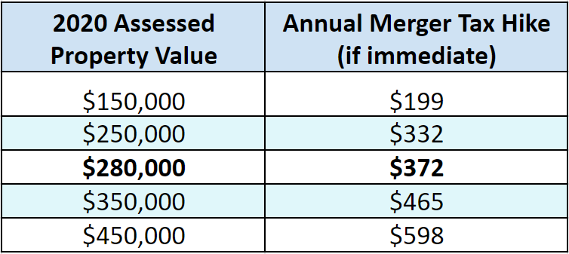

Contribute to   
NoMergerNow

*$372 on a $280,000 property comes from the Town Finance Director (FY22)*

**You’ll be told the Merger Tax Shift is $29 /year for 13 years on a $280,000 TOV property. Actually, it’s a compounded $29 /year /year, on top of your typical Town tax increase:**

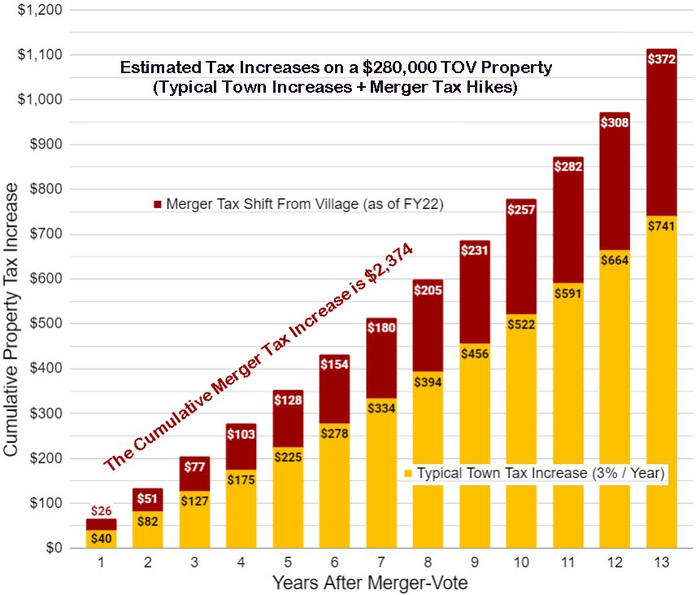

*Merger tries to solve the problem of a bloated Village budget … by shifting costs that Village voters alone approved, for services they receive, to the entire Town. Just Vote NO!*